- “Keep Application Services thin, using them only to coordinate tasks on the domain model.” (Vaughan Vernon, IDDD)

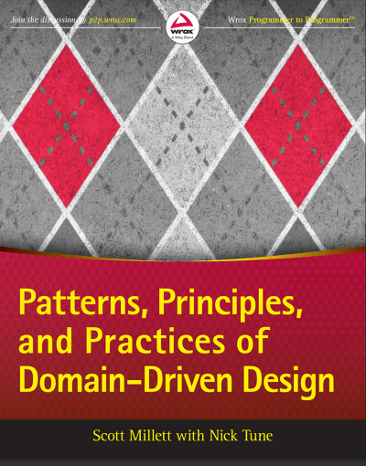

Chapter 25 Commands: Application Service Patterns for Processing Business Use Cases
Many of Domain‐Driven Design (DDD’s) benefits arise from disciplined use of a project’s ubiquitous language (UL)—both in conversation and in code. One of the big challenges you face, though, is maintaining explicitness of domain concepts in code as you try to keep them isolated from purely technical concerns. For instance, when you are knowledge‐ crunching with domain experts, talking them through your domain model, it’s not ideal to clutter your thinking—or the conversation—with threads, sockets, or database connections. Therefore, to maximize the explicitness of your domain model, a clear separation between real‐world domain concepts and purely technical concerns is highly desirable. This separation is one of the important roles carried out by application services, which belong to the application service layer.
Logically, the application service layer sits above the domain and is dependent upon it. This means that a crucial responsibility of application services is to coordinate with the domain to carry out full business use cases. As part of this responsibility, an application service has to translate inputs and outputs to protect domain structure, and it often needs to communicate with other bounded contexts using REST, messaging, and other concepts discussed in Part II, “Strategic Patterns: Communicating Between Bounded Contexts.” Figure 25-1 provides a high‐level illustration of the role of application services.
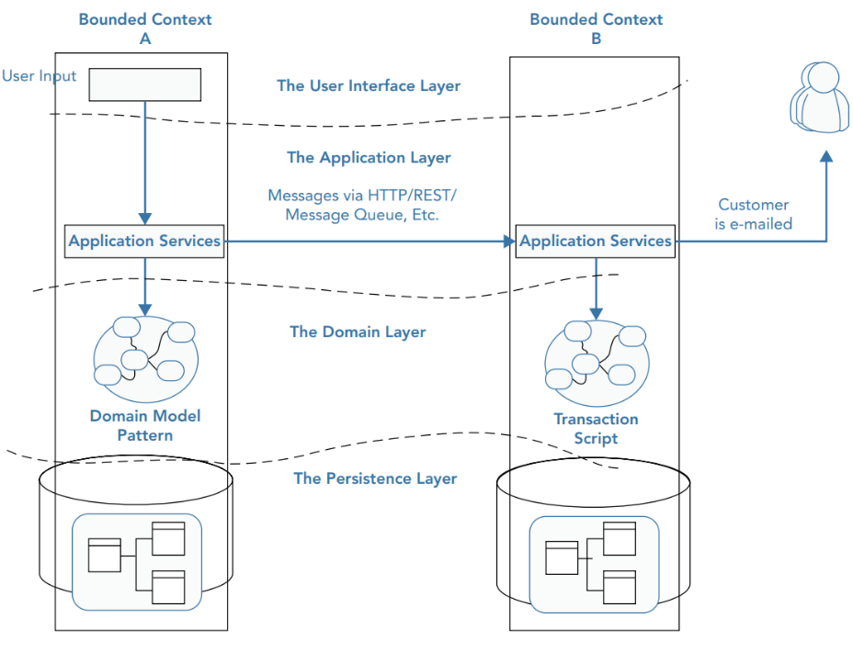
Figure 25-1: Where application services fit in.
Figure 25-1 sets the context for this chapter by visualizing how application services mediate between the domain and external services such as other bounded contexts. Before moving on to technical examples that demonstrate the responsibilities of application services, it is important to be clear about the distinction between application and domain logic. Even for experienced DDD practitioners, there are occasionally some challenges with this distinction.

DIFFERENTIATING APPLICATION LOGIC AND DOMAIN LOGIC
Understanding the difference between application logic and domain logic is crucial if you want to produce a model that accentuates domain concepts and isolates them from purely technical details. For the most part, it is not a difficult task, although there is a small gray area. This section aims to provide a clear picture so you rarely have to worry about where your code should live.

Application Logic
As a starting point, you can think of application services as having two general responsibilities. First, they are responsible for infrastructural concerns: managing transactions, sending e‐mails, and similar technical tasks. In addition, application services have to coordinate with the domain to carry out full business use cases. Carrying out these responsibilities correctly helps prevent domain logic from being obfuscated or incorrectly located in application services.
To demonstrate the role of application services, this section walks through the creation of an application service that can be used in an online gambling application. It manages the Recommend‐a‐Friend use case, in which loyal gamblers are rewarded with $50 of free credit if they can entice their friends to sign up. Their friends are also rewarded with a $50 credit when their account is created. As an extra bonus, the business has decided the referrer’s loyalty status should be upgraded to gold. Figure 25-2 illustrates the Recommend‐a‐Friend use case.
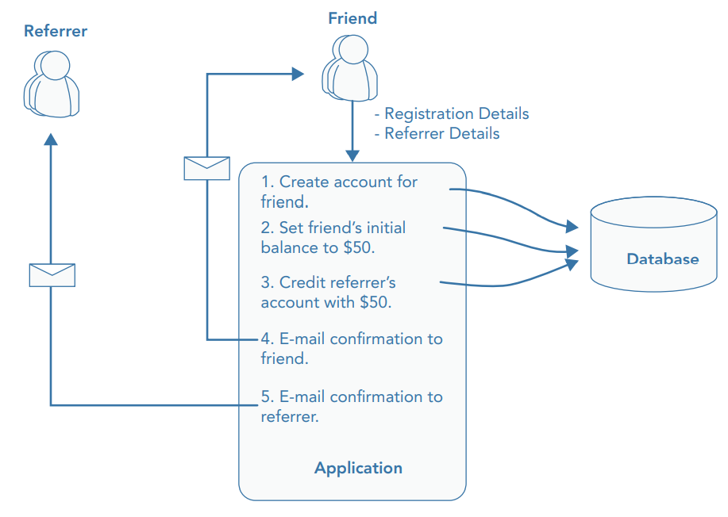
Figure 25-2: The Recommend‐a‐Friend use case.

Infrastructural Concerns
To invoke the functionality of your domain model, you need to carry out a number of infrastructural tasks. Setting up database connections is one common example. When you do a good job of isolating this infrastructural code, you’re rewarded with a more maintainable domain model, free from technical clutter. In the following short sections, you see examples of infrastructural concerns being handled in the RecommendAFriendService—an application service that is responsible for carrying out the Recommend‐a‐Friend use case in the online gambling scenario. One of the first tasks this application service has to deal with, like many others, is validating inputs.
NOTE Adding the “service” suffix to the name of an application service is debatable. This chapter uses the “service” suffix as a learning aid, but it is not essential in your systems.

Application-Level Validation
Examples of application‐level validation include checking that parameters are the correct data type, the correct format, and the correct length. They aren’t business rules that domain experts care about, but they can still cause error conditions in a system. Rather than cluttering domain logic with these technical details, you can perform this type of validation in application services. The RecommendAFriendService takes the account ID of the referrer and basic account details of the friend who is signing up. An initial implementation of the RecommendAFriendService carrying out application-level validation is shown in Listing 25‐1’
LISTING 25‐1: RecommendAFriendService Performing Application‐Level Validation
public class RecommendAFriendService
{
public void RecommendAFriend(int referrerId, NewAccount friendsAccountDetails)
{
Validate(friendsAccountDetails);
...
}
// technical validation carried out at the application level
private void Validate(NewAccount account)
{
if (!account.Email.Contains("@"))
throw new ValidationFailure("Not a valid email address");
if (account.Email.Length >= 50)
throw new ValidationFailure(
"Email address must be less than 50 characters"
);
if (account.Nickname.Length >= 25)
throw new ValidationFailure(
"Nickname must be less than 25 characters"
);
if (String.IsNullOrWhiteSpace(account.Email))
throw new ValidationFailure("You must supply an email");
if (String.IsNullOrWhiteSpace(account.Nickname))
throw new ValidationFailure("You must supply a Nickname");
}
}
public class NewAccount
{
public string Email { get; set; }
public string Nickname { get; set; }
public int Age { get; set; }
}
public class ValidationFailure : Exception
{
public ValidationFailure(string message) : base(message) { }
}
Listing 25‐1 exemplifies the role of application‐level validation. Each clause in Validate() checks a technical detail such as string length or string format in the case of an e‐mail. None of them are a business rule, and none of them belong in the domain.

Transactions
In a typical business use case there are often multiple actions that need to succeed or fail together inside a transaction. By managing transactions in application services, you have full control over which operations that you request of the domain will live inside the same transaction boundary. This can be demonstrated using an updated RecommendAFriendService. Imagine the business has decided that if the referral policy cannot be applied, it should not create the new account. Therefore, the transactional boundary encapsulates creating the new account and applying the referral policy to both accounts, as shown in Figure 25-3. Using the .NET Framework’s TransactionScope, you can add transactional behavior to the RecommendAFriendService, as shown in Listing 25‐2. Not all databases, ORMs, and other frameworks use TransactionScope, but application programming interfaces (APIs) for creating, committing, and aborting transactions are usually similar.
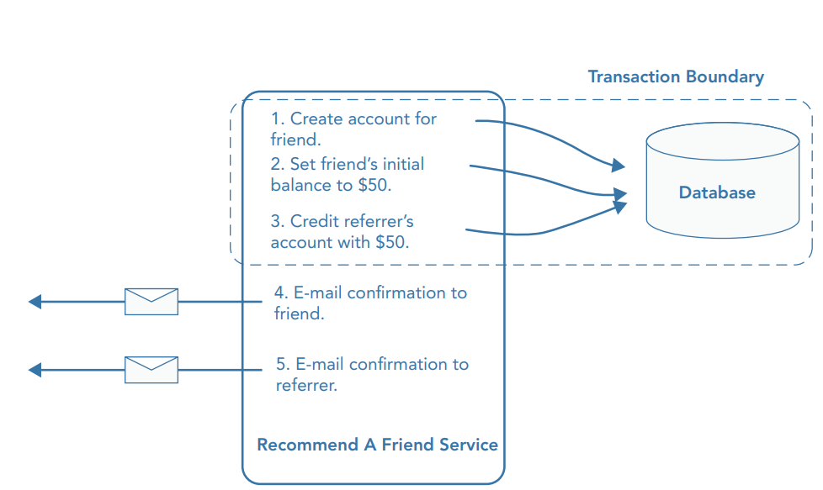
FIGURE 25‐3: Transactional boundary for Recommend-a-Friend
LISTING 25‐2: RecommendAFriendService to Handle Transactions
public void RecommendAFriend(int referrerId, NewAccount friendsAccountDetails)
{
Validate(friendsAccountDetails);
// most technologies have similar transaction APIs
using (var transaction = new System.Transactions.TransactionScope())
{
try
{
// ... interact with domain multiple times
transaction.Complete();
}
catch
{
// transaction will roll back if Complete() not called
}
}
}

Error Handling and Error Translation
Not all interactions with the domain will be successful. In such cases, the domain will likely throw exceptions or return error codes. These are cases in which domain validation fails (even though application‐level validation was successful). An application service’s job is to handle these error conditions and translate them into suitable representations for external parties, so that no external parties are coupled to the structure of the domain errors. External parties could be either human users of a website or other software systems. One domain error that can occur in the Recommend‐a‐Friend use case is when the referrer has a long‐term outstanding balance. The business has decided that these customers should not be rewarded with a loyalty bonus. Because the domain will notify of this error condition, the RecommendAFriendService is responsible for handling the error and transforming it into a suitable external representation, as shown in Listing 25‐3.
LISTING 25‐3: RecommendAFriendService Handling and Translating Domain Errors
public void RecommendAFriend(int referrerId, NewAccount friendsAccountDetails)
{
Validate(friendsAccountDetails);
// most technologies have similar transaction APIs
using (var transaction = new System.Transactions.TransactionScope())
{
try
{
// ... interact with domain multiple times
transaction.Complete();
}
catch(ReferralRejectedDueToLongTermOutstandingBalance)
{
throw new ApplicationError(
"Sorry, this referral cannot be completed. The referrer " +
"currently has an outstanding balance. Please contact " +
"Customer Services"
);
// transaction will roll back if Complete() not called
}
}
}
NOTE Technically, a TransactionScope will roll back the transaction when its Dispose() method is called if Complete() has not been called. In Listing 25‐3, Dispose() will be called automatically at the end of the using block
Listing 25‐3 shows how application services can protect the domain structure by translating exceptions into a standard format. In this example, the external format is an ApplicationError exception. Using an ApplicationError exception prevents clients of the application service becoming coupled to the domain exception. Instead, clients are coupled to the ApplicationError, which is a more stable interface hiding the potential volatility of the domain.
Using a convention for representing errors, such as an ApplicationError exception, gives you the opportunity to handle all errors consistently. For example, in an ASP.NET MVC application, you can create a HandleErrorAttribute that handles ApplicationErrors. When the filter catches an ApplicationError, it knows that it was thrown by an application service, meaning that it is safe to present the message to the outside world. In contrast, when it catches any other type of exception, it does not know if it is secure to disclose the details of the error, so it has to return a generic error message, as shown in Listing 25‐4
LISTING 25‐4: ASP.NET MVC Error Filter Applying Error Conventions
public class ErrorFilter : HandleErrorAttribute
{
public override void OnException(ExceptionContext filterContext)
{
if (filterContext.Exception.GetType() == typeof(ApplicationError))
{
// return specific message to user
var msg = filterContext.Exception.Message;
ErrorResponse(msg, filterContext);
}
else
{
// return generic message for security reasons
var msg = "Sorry. Something really unexpected has occurred";
ErrorResponse(msg, filterContext);
}
}
public void ErrorResponse(string msg, ExceptionContext ec)
{
var routeData = new RouteValueDictionary(new { message = msg });
var response = new RedirectToRouteResult("ErrorPage", routeData);
ec.Result = response;
ec.ExceptionHandled = true;
}
}

Logging, Metrics, and Monitoring
Response times, errors, and other types of diagnostic information allow you to see how your application is performing and spot any potential issues at an early stage. But capturing this information can add unnecessary clutter to your domain logic and obfuscate important concepts. Sometimes you have to suffer this pain, but on many occasions, you can lean on application services to report this information instead. Listing 25‐5 shows an updated version of the RecommendAFriendService that logs the duration of each action and whether the overall result is an exception or a success so that the code does not have to be added to the domain model.
LISTING 25‐5: RecommendAFriendService Capturing Logs and Metrics
public void RecommendAFriend(int referrerId, NewAccount friendsAccountDetails)
{
Validate(friendsAccountDetails);
using (var transaction = new System.Transactions.TransactionScope())
{
try
{
// ... interact with domain multiple times
transaction.Complete();
// log here to avoid cluttering domain
logger.Debug("Successful friend recommendation");
StatsdClient.Metrics.Counter("friendReferrals");
}
catch (ReferralRejectedDueToLongTermOutstandingBalance ex)
{
// log here to avoid cluttering domain
logger.Error(ex);
StatsdClient.Metrics.Counter("ReferralRejected");
throw new ApplicationError(
"Sorry, this referral cannot be completed. The referrer " +
"currently has an outstanding balance. Please contact " +
"customer support"
);
}
}
}
The key details to look for in Listing 25‐5 are the usages of logger.Debug(), logger.Error(), and StatsDClient.Metrics(). Each of these method calls could have easily ended up mixed in with domain logic. Instead, each has been brought up into the application service.

Authentication and Authorization
A common infrastructural concern that most applications are forced to deal with is authentication. To demonstrate authentication in the Recommend‐a‐Friend scenario, this example models the case in which customer support is logging in to the admin interface and manually triggering the referral policy because there was a problem when the new customer signed up. Listing 25‐6 shows how the AdminRecommendAFriendService checks whether the user is authenticated before it applies the referral policy.
LISTING 25‐6: AdminRecommendAFriendService Ensuring User Is Authenticated
public class AdminRecommendAFriendService
{
private IAuthenticationService authentication;
...
public void RecommendAFriend(int referrerId, int friendId)
{
if (!authentication.IsLoggedInUser())
throw new AuthenticationError();
// look up customers
// apply referral policy
}
}
For many applications, authentication isn’t a strong enough security measure, and authorization is additionally required. Authorization is the process that checks whether users have the appropriate privileges to carry out the requested action. Therefore, it’s an important tool in applications that have different types of users with different privileges.
Assuming that the AdminRecommendAFriendService is part of an application that contains a number of different users—customers and admins—authorization will be required to prevent normal users from applying the referral policy; business would be negatively affected if users could continually top up their online gambling account with free credits by just hacking a few uniform resource locators (URLs). (This does happen.) An upgraded version of the AdminRecommendAFriendService that performs an admin authorization check is shown in Listing 25‐7.
LISTING 25‐7: AdminRecommendAFriendService Ensuring User Is Authorized to Apply Policy
public class AdminRecommendAFriendService
{
private IAuthenticationService authentication;
private IAuthorizationService authorization;
// .. constructor
public void RecommendAFriend(int referrerId, int friendId)
{
if (!authentication.IsLoggedInUser())
throw new AuthenticationError();
if (!authorization.IsCurrentUserAdmin())
throw new AuthorizationError();
// apply referral policy
}
}
Communication
Events that happen inside a domain from one bounded context may trigger events that are handled by other bounded contexts. You saw examples of this in Part II with the messaging and REST examples. It is the responsibility of an application service to transmit events between bounded contexts. This may involve publishing messages using a message bus (see Chapter 12, “Integrating Via Messaging,” for detailed examples) or an atom feed (see Chapter 13, “Integrating Via HTTP with RPC and REST,” for detailed examples), or other kinds of communication. Importantly, again, the goal is to decouple domain concepts from infrastructural concerns. Listing 25‐8 shows an updated version of the RecommendAFriendService that also publishes events using NServiceBus.
LISTING 25‐8: RecommendAFriendService Publishing Event
public class RecommendAFriendService
{
private ICustomerDirectory customerDirectory;
private IReferAFriendPolicy referAFriendPolicy;
private IBus bus;
public RecommendAFriendService(ICustomerDirectory customerDirectory,
IReferAFriendPolicy referAFriendPolicy, IBus bus)
{
this.customerDirectory = customerDirectory;
this.referAFriendPolicy = referAFriendPolicy;
this.bus = bus;
}
public void RecommendAFriend(int referrerId, NewAccount friendsAccountDetails)
{
Validate(friendsAccountDetails);
using (var transaction = new System.Transactions.TransactionScope())
{
try
{
var referrer = customerDirectory.Find(referrerId);
var friend = customerDirectory.Add(friendsAccountDetails);
referAFriendPolicy.Apply(referrer, friend);
transaction.Complete();
var msg = new CustomerRegisteredViaReferralPolicy
{
ReferrerId = referrerId,
FriendId = friend.Id
};
bus.Publish(msg);
}
catch (ReferralRejectedDueToLongTermOutstandingBalance)
{
var msg = new ReferralSignupRejected
{
ReferrerId = referrerId,
FriendEmail = friendsAccountDetails.Email,
Reason = "Referrer has long term outstanding balance"
};
bus.Publish(msg);
}
}
}
private void Validate(NewAccount account)
{
...
}
}
Although Listing 25‐8 shows an application service communicating via NServiceBus, the method of communication could be a remote procedure call (RPC), REST, or another. Application services should also be used to handle other concerns presented in Part II of the book, including handling external events, handling and publishing internal events (such as the messaging gateway in Chapter 12), and producing an atom feed

Coordinating Full Business Use Cases
Looking back to the latest version of the RecommendAFriendService in Listing 25‐8, you can see it handles a lot of infrastructural concerns that do not intrinsically add business value. They are only there to support the second major responsibility of application services that does add value— coordinating the domain model to carry out full business use cases. Listing 25‐9 shows a section of an updated version of the RecommendAFriendService that builds on the infrastructural foundations by coordinating the domain to carry out the Recommend‐a‐Friend use case.
LISTING 25‐9: RecommendAFriendService Fulfilling Use Case by Interacting with Domain
try
{
// customerDirectory is a domain repository
Customer referrer = customerDirectory.Find(referrerId);
Customer friend = customerDirectory.Add(friendsAccountDetails);
// RecommendAFriendPolicy is a domain policy
RecommendAFriendPolicy.Apply(referrer, friend);
transaction.Complete();
// log here to avoid cluttering domain
logger.Debug("Successful friend recommendation");
StatsdClient.Metrics.Counter("friendReferrals");
}
You can see the customerDirectory and RecommendAFriendPolicy variables being used in Listing 25‐9. They represent domain objects and are used in this example to exemplify how an application service has to interact multiple times with the domain to carry out the entire use case. Here, it fetches the referrer, asks the domain to create the new customer, and finally tells the domain to apply the policy.

Application Services and Framework Integration
Application services are notorious for becoming bloated with loosely related logic that doesn’t appear to belong anywhere else. Sometimes chunks can be refactored into their own classes. In the RecommendAFriendService, Validate() is a good candidate for moving into its own class. Another source of bloat found in application services is boilerplate duplication. In the RecommendAFriendService, the transaction code is typical boilerplate code that could end up being duplicated in every application service. You could create a base application service that follows the Template Method pattern, or you could create a utility that takes a lambda and wraps it with a transaction.
Even with the patterns just mentioned, there is sometimes a cleaner solution than using all‐ encompassing application services. Many modern frameworks provide hooks for you to inject your infrastructural concerns. ASP.NET MVC is a good example. It has the concept of ActionFilters, which act like a pipeline. Using action filters, you can inject filters that handle validation, opening and closing transactions, logging, and other infrastructural concerns. Listing 25‐10 shows an example TransactionFilter ActionFilter.
LISTING 25‐10: Action Filter for Framework Integration with ASP.NET MVC
public class TransactionFilter : ActionFilterAttribute, IActionFilter
{
// executes before controller
public override void OnResultExecuting(ResultExecutingContext filterContext)
{
// start a transaction
var t = new TransactionScope();
HttpContext.Current.Items["transaction"] = t;
base.OnResultExecuting(filterContext);
}
// executes after controller
public override void OnActionExecuted(ActionExecutedContext filterContext)
{
// close the transaction created at start of this request
var t = (TransactionScope)HttpContext.Current.Items["transaction"];
t.Complete();
base.OnActionExecuted(filterContext);
}
}
When the framework takes care of all your infrastructural concerns, the need for an application service is debatable. Instead, you may be tempted to put your few lines of domain model coordination directly inside a controller, as Listing 25‐11 does.
LISTING 25‐11: Moving Coordination Logic Directly into the Controller
public class RecommendAFriendController : Controller
{
private ICustomerDirectory directory;
private IRecommendAFriendPolicy policy;
public RecommendAFriendController(
ICustomerDirectory customerDirectory, IRecommendAFriendPolicy policy)
{
this.directory = customerDirectory;
this.policy = policy;
}
// all infrastructure concerns handled by framework
public ActionResult Index(int referrerId, NewAccount friend)
{
var referrer = directory.Find(referrerId);
var newAcct = directory.Create(friend);
policy.Apply(referrer, newAcct);
return View();
}
}
As enticing as frameworks are, there is a big gotcha to be aware of. If you are using the application service in multiple places—perhaps a web front end and a desktop front end—then using an all‐ encompassing application service may prevent you from having to duplicate the infrastructural logic in both front ends. You need to make a per‐project decision about how tightly you want to couple yourself to the frameworks you are using.

Domain Logic from an Application Service’s Perspective
A challenging activity for many DDD practitioners is drawing the line between application logic and domain logic. Infrastructural concerns are normally easy to identify, but the coordination logic that pieces together full use cases can sometimes appear to contradict the “No business rules in application services” principle. If you look back to Listing 25‐9, you can see three interactions with the domain: fetching the referrer, asking the domain to create the new customer, and applying the policy. Some would argue that this logic should live in the domain.
One approach to deciding if a sequence of interactions belongs in the domain is to ask, “Should this always happen?” or “Are these steps inextricable?” If so, that sounds like a domain policy, because those steps always have to happen together. However, if those steps can be recombined in a number of ways, potentially it’s not a domain concept. In the Recommend‐a‐Friend use case, you might argue that the referral policy should only ever be applied to an existing customer (the referrer) and a new customer (the referrer’s friend). It follows, then, that the logic in the application service is actually a business rule that may be best encapsulated inside a domain service. However, sometimes the business wants to apply the policy to two existing accounts if there was an error during creation. In that case, the creation of the new account and the policy aren’t as coupled, suggesting this is application logic.
A sign that you have avoided leaking domain concepts into application services is that each interaction with the domain is expressive. An example of this is RecommendAFriendPolicy.Apply(). The implementation of this method credits each account with $50 and promotes the referrer to gold loyalty status. If those steps lived in the application service, it would be less expressive, more verbose, and a big sign that domain concepts had leaked out of the domain”

APPLICATION SERVICE PATTERNS
You can use a variety of design patterns and principles inside application services based on your preferences and based on context. In the RecommendAFriendService from the previous section, you saw vanilla, script‐like, object‐oriented code. In many cases, that is the simplest possible solution and a good choice. On other occasions, you may find it presents maintenance headaches or undesirable coupling. The following patterns have arisen within the community for addressing concerns like these.

Command Processor
Using the command processor pattern, you can avoid developing large application services with many concerns. Instead, you have a command and a processor for each use case. Listing 25‐12 shows a monolithic application service that can be considered to have multiple responsibilities.
LISTING 25‐12: Potentially Monolithic Application Service
public class BloatedRecommendAFriendService
{
public void RecommendAFriend(int referrerId, NewAccount friend)
{
...
}
public void RecommendAFriendInDifferentCountry(int referrerId,
NewAccount friend)
{
...
}
public void ReverseFriendReferral(int referrerId, int friendId)
{
...
}
public void ReferAFriendWithoutLoyaltyBonus(int referrerId, NewAccount friend)
{
...
}
// more methods like this
}
Friction can occur when you have application services like the BloatedRecommendAFriendService in Listing 25‐12. The implementations for each method may vary considerably, with each using different dependencies. Low cohesion is especially common in applications that use CQRS. Consequently, the application service can grow into a source of development friction. The command processor pattern can be used to alleviate these pains. To create an alternative version of the BloatedRecommendAFriendService using the command processor pattern, the first step is to create a command that expresses intent and contains all the relevant information needed for it to be carried out. You can see an example of this in Listing 25‐13.
LISTING 25‐13: RecommendAFriend Command
// command expressing intent
public class RecommendAFriend
{
public int ReferrerId { get; set; }
public NewAccount Friend { get; set; }
}
After creating the command, you then create a command processor. An interface for a command processor that processes RecommendAFriend commands is shown in Listing 25‐14.
LISTING 25‐14: RecommendAFriendProcessor Command Processor Interface
public interface IRecommendAFriendProcessor
{
void Process(RecommendAFriend command);
}
Creating a command and processor as above is fundamentally just a case of creating a separate interface for each use case in the application, with the aim of isolating responsibilities and increasing expressiveness. But many DDD practitioners have taken the pattern further by adding a layer of indirection that provides looser coupling and the ability to chain command processors. Chaining can be used to create a pipeline that carries out infrastructural concerns such as validation, transactions, and logging, allowing you to isolate domain coordination. This version of the pattern requires common processor interfaces, as shown in Listing 25‐15.
LISTING 25‐15: Common Command Processor Interface
public interface ICommandProcessor<T>
{
void Process(T command);
}
Each command processor then implements this interface so they can be chained together. First, you want to create a handler that is specific to the use case you are implementing. In this case, that would be a RecommendAFriendProcessor, as shown in Listing 25‐16.
LISTING 25‐16: Use Case‐Specific Command Processor
public class RecommendAFriendProcessor : ICommandProcessor<RecommendAFriend>
{
public void Process(RecommendAFriend command)
{
Console.WriteLine("Processing RecommendAFriend command");
}
}
Generic command processors that you can apply to any use case also need to implement the ICommandProcessor interface. You can see demonstrative logging and transaction processors in Listing 25‐17.
LISTING 25‐17: Generic Processors That Can Be Applied to Any Use Case
public class LoggingProcessor<T> : ICommandProcessor<T>
{
private ICommandProcessor<T> nextLinkInChain;
public LoggingProcessor(ICommandProcessor<T> processor)
{
this.nextLinkInChain = processor;
}
public void Process(T command)
{
// log something before
nextLinkInChain.Process(command);
// log something after
}
}
public class TransactionProcessor<T> : ICommandProcessor<T>
{
private ICommandProcessor<T> nextLinkInChain;
public TransactionProcessor(ICommandProcessor<T> processor)
{
this.nextLinkInChain = processor;
}
public void Process(T command)
{
// start transaction
try
{
nextLinkInChain.Process(command);
// commit transaction
}
catch
{
// roll back transaction
}
}
}
When you’re looking at Listing 25‐17, the most important detail to discern is that each command processor takes another processor in its constructor. When a processor processes a command, it invokes the processor passed into its constructor. Essentially, it is wrapping (or decorating) the “child” processor to create a pipeline that can be infinitely long. Another important detail to be aware of occurs inside Process(). A processor can perform logic before and after the processor it wraps. As you can see with the TransactionProcessor, it starts a transaction, invokes the child (which may invoke other children), and then commits or rolls back the transaction depending on whether the wrapped processor threw an exception.
NOTE The TransactionProcessor in Listing 25‐17 contains try/catch logic. In your applications, you may want to move this into a separate error‐handling processor.
Wiring up command processors is the last remaining detail. You can see the simplest possible version of this in Listing 25‐18. If you compare the code with Figure 25‐17, it should help you see how the pipeline is being created.
LISTING 25‐16: Use Case‐Specific Command Processor
public class RecommendAFriendProcessor : ICommandProcessor<RecommendAFriend>
{
public void Process(RecommendAFriend command)
{
Console.WriteLine("Processing RecommendAFriend command");
}
}
There are other ways of wiring up pipelines than that shown in Listing 25‐18. Some teams do prefer to manually wire up each pipeline in a similar fashion to this using a few helper methods to avoid duplication. Other teams prefer to use dependency injection. It’s completely up to you to decide how to configure your pipelines.

Publish/Subscribe
A pattern for looser coupling is publish/subscribe, whereby application services subscribe to events in the domain. You may want to consider this pattern when your domain logic is inherently event based, especially when you pass commands into the domain but do not receive a return value. An interface for an event‐based version of the ReferralPolicy is shown in Listing 25‐19.
LISTING 25‐19: Event‐Based Interface for the ReferralPolicy
public interface IReferralPolicy
{
event EventHandler<Referral> ReferralAccepted;
event EventHandler<Referral> ReferralRejected;
void Apply(RecommendAFriend command);
}
To use the IRefferalPolicy in Listing 25‐19, an application service passes a command into Apply() as usual. However, to learn whether the command was successful, the application service has to subscribe to the two events: ReferralAccepted and ReferralRejected. This pattern is illustrated in Listing 25‐20.
LISTING 25‐20: Subscribing to Events on a Domain Model
public class RecommendAFriendService
{
private IReferralPolicy policy;
public RecommendAFriendService(Domain.IReferralPolicy policy)
{
// subscribe to events on domain model
policy.ReferralAccepted += HandleReferralAccepted;
policy.ReferralRejected += HandleReferralRejected;
this.policy = policy;
}
private void HandleReferralAccepted(object sender, Domain.Referral e)
{
// send confirmation e-mails, etc.
}
private void HandleReferralRejected(object sender, Domain.Referral e)
{
// send rejection e-mails, etc.
}
public void RecommendAFriend(int referrerId, NewAccount friend)
{
var command = new RecommendAFriend
{
ReferrerId = referrerId,
Friend = friend
};

policy.Apply(command);
}
}
Subscription to the IReferralPolicy’s events occurs in the RecommendAFriendService’s constructor shown in Listing 25‐20. Anytime the domain model fires either of those events, the appropriate handler is called: HandleReferralAccepted() or HandleReferralRejected(). These events are triggered by passing commands into the domain model, as occurs inside RecommendAFriend().
A problem with the code in Listing 25‐20 is that it cannot handle transactions properly because the event handlers do not have access to the transaction object to commit or roll back. A solution to this problem is to have an instance field as a transaction. For this to work, though, you have to ensure that a new instance of the RecommendAFriendService is created for each new transaction to avoid multithreading issues.
Another transaction‐related problem with the code in Listing 25‐20 occurs in multithreading scenarios. Consider the case in which the command is applied asynchronously in another thread using a C# task:
Task.Factory.StartNew(() => policy.Apply(command));
The transaction scope wrapping this call is no longer in scope when Apply() is called asynchronously. Fortunately, .NET’s TransactionScope has modes that help in async scenarios (http://stackoverflow.com/questions/13543254/get‐transactionscope‐to‐work‐with‐ async‐await). When using transactions and threads like this, you still need to be careful. You may also want to consider using async/await.

Request/Reply Pattern
Before choosing patterns with a higher complexity trade‐off, it’s always worth considering the simplicity of the request/reply pattern. This pattern follows the One Model In One Model Out Approach (OMIOMO), where a data transfer object (DTO) is passed into the application service and a DTO is returned, as Listing 25‐21 demonstrates.
………..

TESTING APPLICATION SERVICES
………..

Use Domain Terminology

Test as Much Functionality as Possible

THE SALIENT POINTS
➤ Application services and a service layer allow you to isolate technical concerns from domain logic.
➤ Technical concerns include transactions, database connections, and e‐mails.
➤ Application services are responsible for coordinating with the domain to carry out full business use cases.
➤ When communicating with the domain, application services should invoke expressive high‐level APIs on domain objects.
➤ An important responsibility of application services is to protect domain structure by presenting higher layers and external components with more stable interfaces to couple themselves to.
➤ You can use design patterns like the command processor pattern and asynchronous patterns in the service layer.
➤ Testing application services is an opportunity to express high‐level behaviors or full business use cases, in the ubiquitous language, while covering a high percentage of the implementation.

